INEZA TANIA HORLINE

ID:25797

OOP ASSIGNMENT

1. IOException

Occurs during input/output operations. For example, reading a non-existent file.

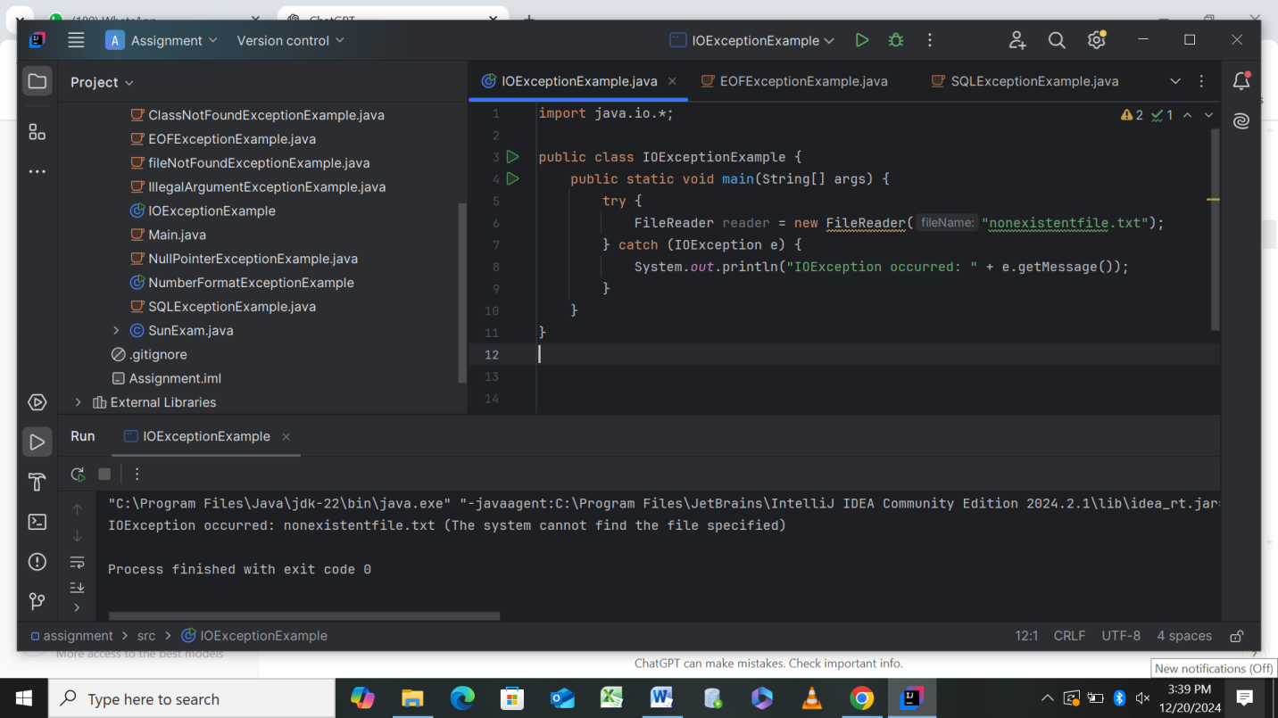

1. FileNotFoundException

A specific type of IOException triggered when a file is not found.

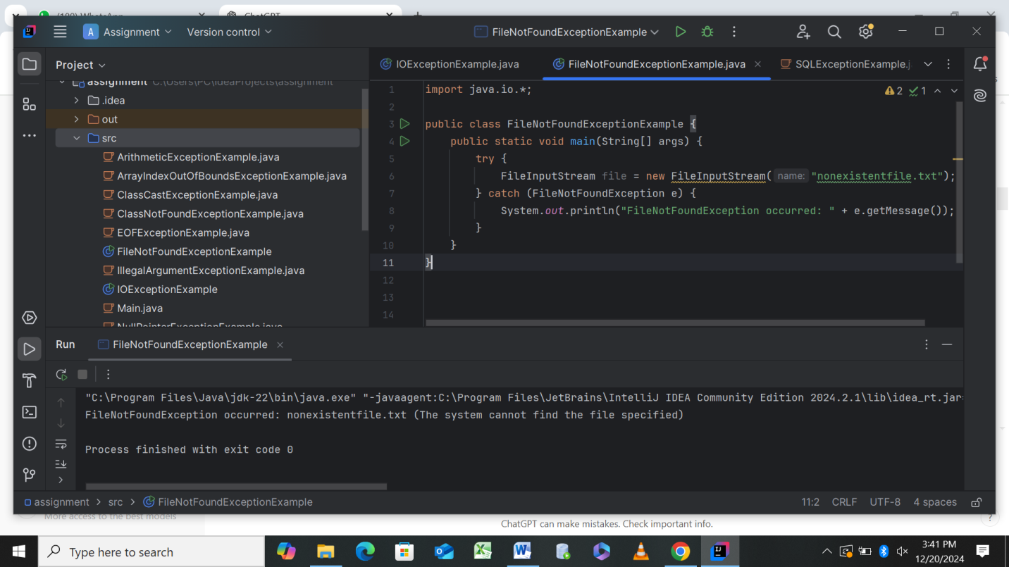

1. EOFException

Triggered when trying to read beyond the end of a file.

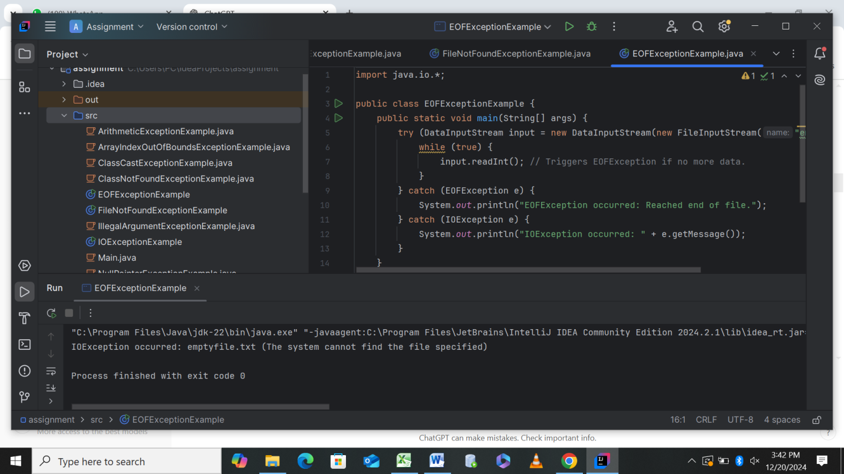

1. SQLException

Occurs when there’s a database-related issue, like connecting to a non-existent database.

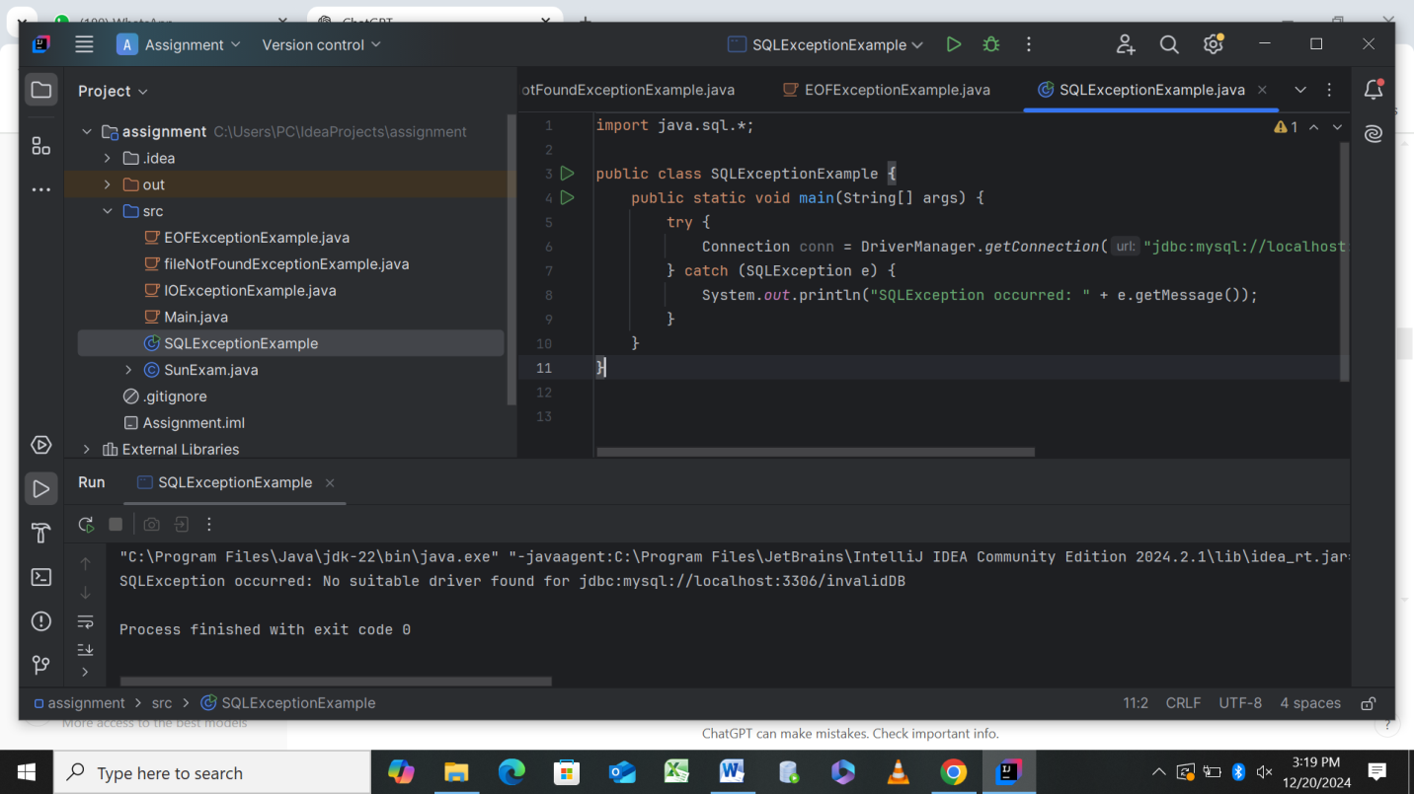

1. ClassNotFoundException

Triggered when attempting to load a missing class dynamically.

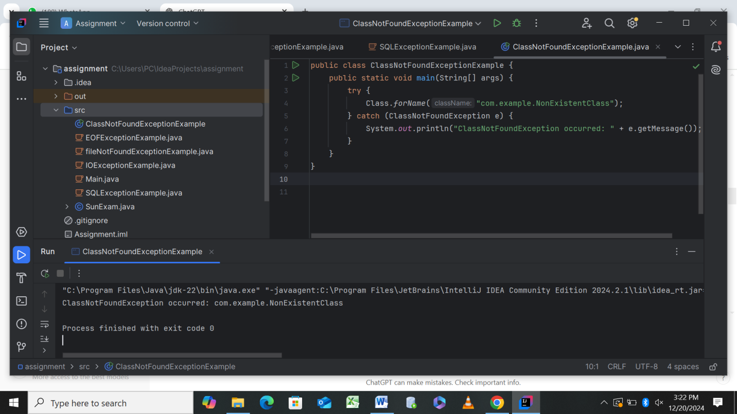

1. ArithmeticException

Occurs when performing an illegal arithmetic operation, like division by zero.

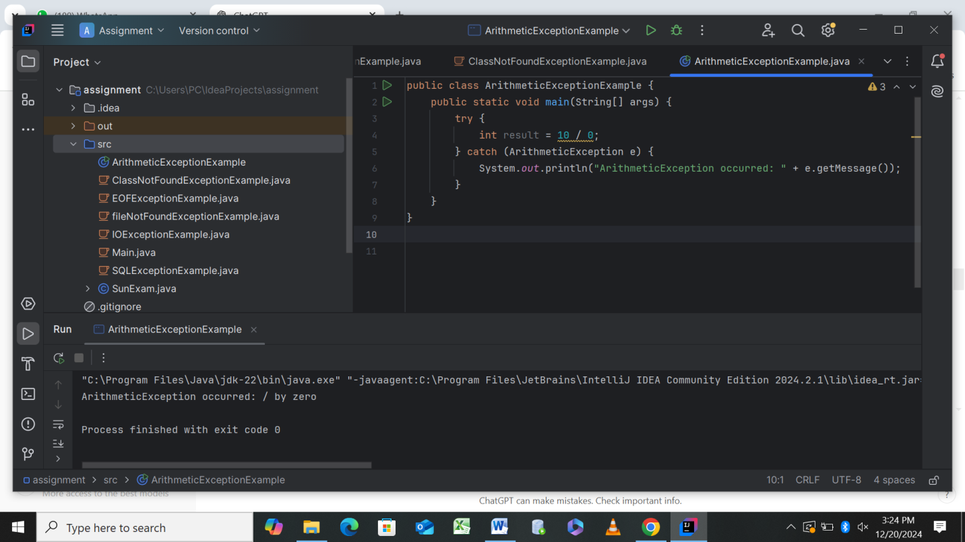

1. NullPointerException

Triggered when accessing an object reference that is null.

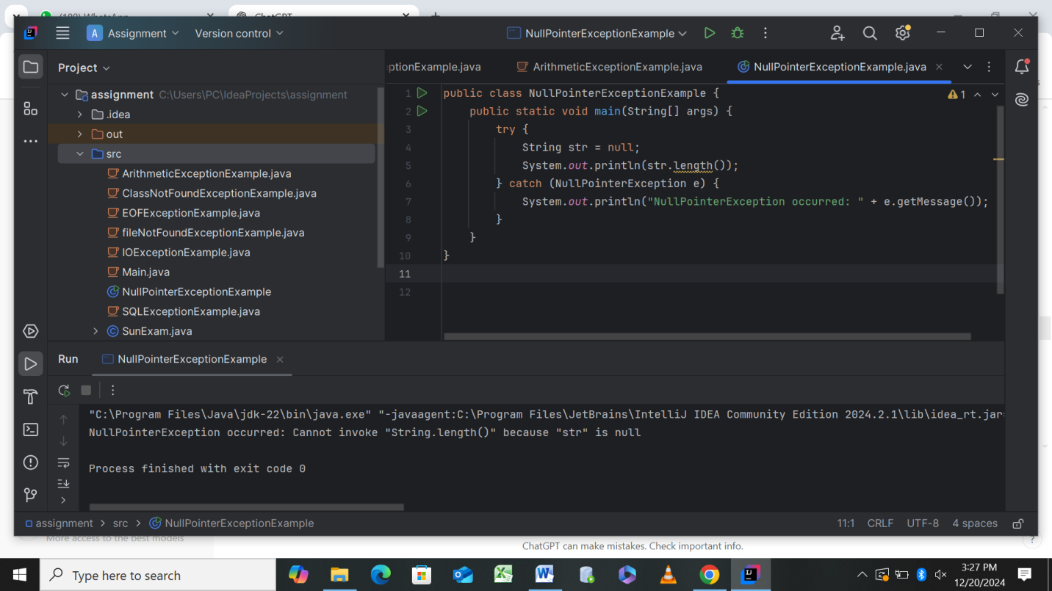

1. ArrayIndexOutOfBoundsException

Triggered when accessing an array with an invalid index.

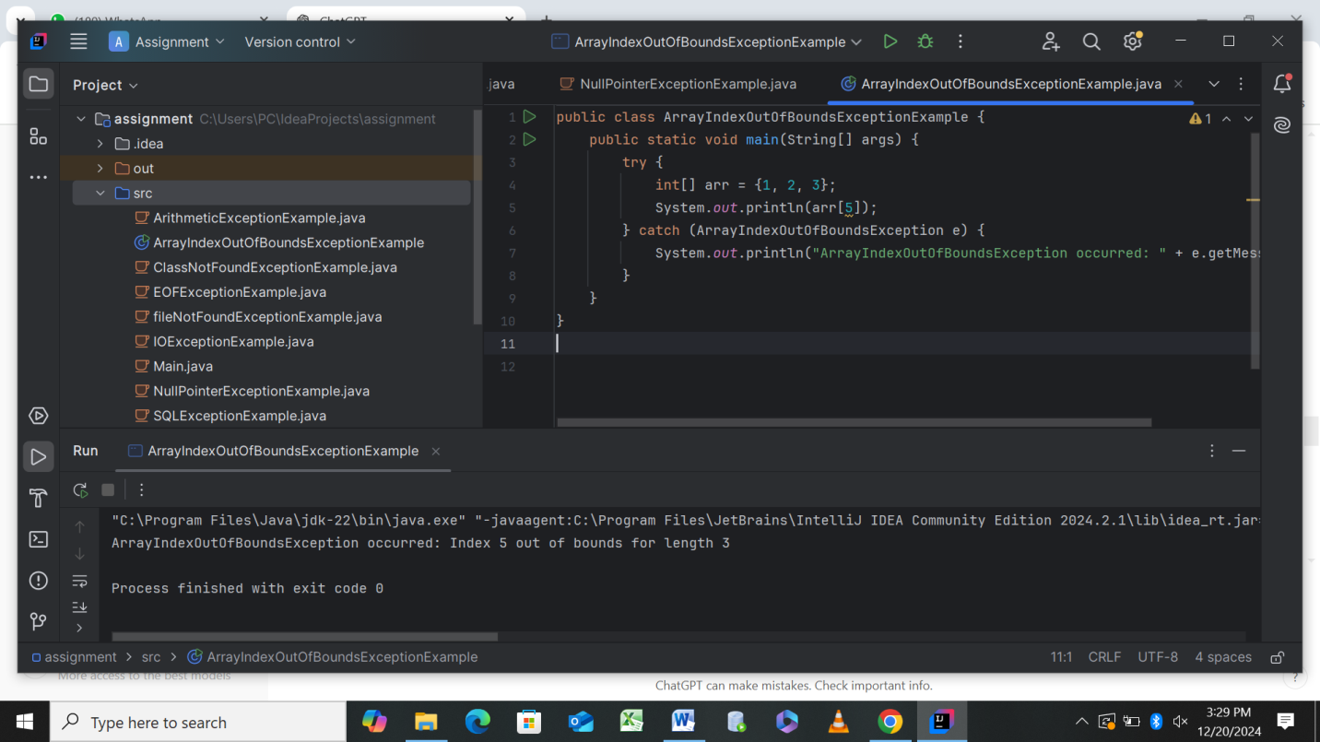

1. ClassCastException

Occurs when attempting an invalid type conversion.

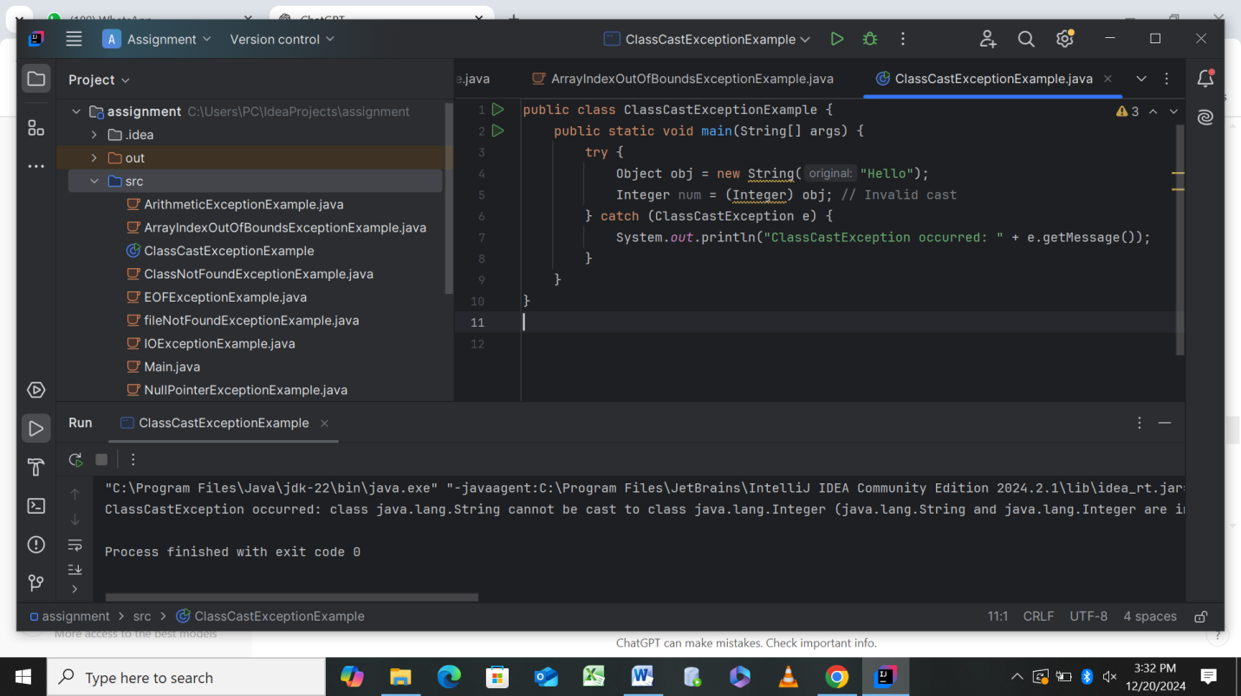

1. IllegalArgumentException

Triggered when a method receives an invalid argument.

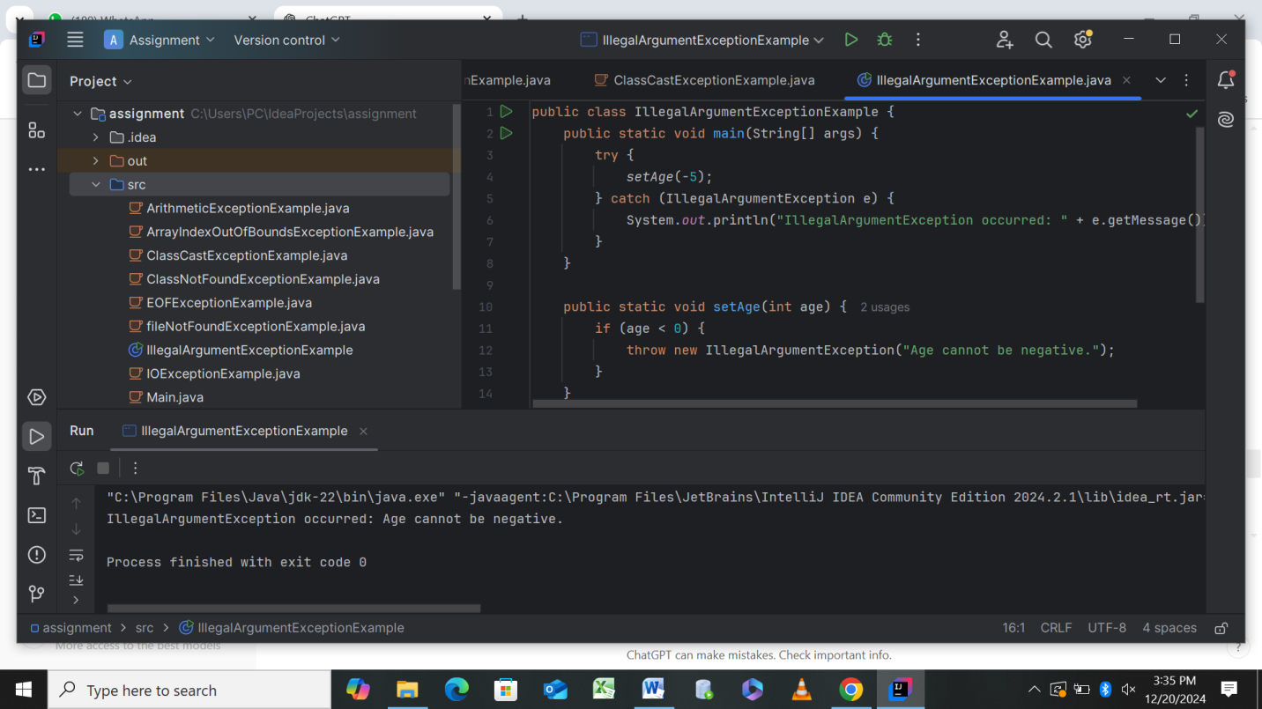

1. NumberFormatException

Occurs when trying to convert an invalid string to a number.

